# NSWPPA State Council Workshop – Association future directions through Reference Group, Standing Committee and Working Party

***Term 4 2018***

#### Background...

**Our leadership is evidenced by:**

* Providing a voice for primary principals to influence policy & direction of the Ministry & Department of Education
* Providing & support evidence informed & current professional learning to develop leadership capacity
* Deliver support for principal wellbeing
* Communicate, collaborate, critically reflect & consult with other peak stakeholder bodies to ensure we achieve priorities

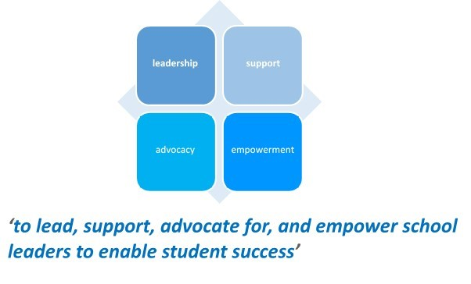

In 2017 – 2018 the NSWPPA continues to focus on the support of Principals and their schools in a changing paradigm. We have identified five broad Priorities which drive our advocacy and support.

**Priority 1: Principal Wellbeing**

**Priority 2: The Principal in a changing environment**

**Priority 3: Learning and Quality Teaching**

**Priority 4: Communication**

**Priority 5: School Operations**

***Purpose****:* *To capture State Council's collective input on future directions for Reference Groups, Standing Committee’s and Working Parties (RG, SC & WP) from State Council for 2019. Through this process the priorities of the Association for the 2019-2020 period will be established.*

***Directions****: Using a brainstorming technique (all suggestions welcome) please list key areas for investigation, follow-up and action beneath each of the RG, SC & WP’s. A staggered starting point for each table group in the room will ensure all RG, SC & WP‘s receive input. You may of course contribute to any of the RG, SC & WP’s.*

**One question to ponder as you work together…**

**Does the current range of Reference Groups, Standing Committees and Working Party meet the needs of NSW Primary Principals and support the Associations purpose?**

**Your thoughts and suggestions for change and maintenance…**



**Now to the RG’s, SC’s & WP…**

***Example…***

**Human Resources Reference Group**

**Future focus:** A revamped Principal Classification

**Desired outcome:** Classification reflects NSWPPA Teaching Principal RG position paper endorsed at State Council Term 4 2018 and includes an expanded range of classification to increase opportunity for primary principal promotion.

**Finance & Administration Reference Group**

**Future focus:** HR SAP Finance HR SAP Payroll & Leave

**Desired outcome:** The two components are fully integrated to automate and remove the burdensome tasks currently required to reconcile casual & temporary staff employment with the schools financial expenditure.

|  |
| --- |
| **Reference Group** |
| **Aboriginal Education**  Future focus:  Desired outcome:  Future focus:  Desired outcome: |
| **Assessment, Planning and Accountabilit**y  Future focus:  Desired outcome:  Future focus:  Desired outcome: |
| **Asset Management**  Future focus:  Desired outcome:  Future focus:  Desired outcome: |
| **Curriculum**  Future focus:  Desired outcome:  Future focus:  Desired outcome: |
| **Disability Programs**  Future focus:  Desired outcome:  Future focus:  Desired outcome: |
| **Finance & Administration**  Future focus:  Desired outcome:  Future focus:  Desired outcome: |
| **Human Resources**  Future focus:  Desired outcome:  Future focus:  Desired outcome: |
| **Principal Support**  Future focus:  Desired outcome:  Future focus:  Desired outcome: |
| **Schools for Specific Purposes**  Future focus:  Desired outcome:  Future focus:  Desired outcome: |
| **Student Wellbeing**  Future focus:  Desired outcome:  Future focus:  Desired outcome: |
| **Teaching Principals**  Future focus:  Desired outcome:  Future focus:  Desired outcome: |
| **Technology**  Future focus:  Desired outcome:  Future focus:  Desired outcome: |
|  |
| **Standing Committee & Working Party** |
| **Annual Conference**  Future focus:  Desired outcome:  Future focus:  Desired outcome: |
| **Communication & Engagement**  Future focus:  Desired outcome:  Future focus:  Desired outcome: |
| **Leadership**  Future focus:  Desired outcome:  Future focus:  Desired outcome: |
| **Legal Issues**  Future focus:  Desired outcome:  Future focus:  Desired outcome: |
| **Rural Education**  Future focus:  Desired outcome:  Future focus:  Desired outcome: |
| **School Viability**  Future focus:  Desired outcome:  Future focus:  Desired outcome: |
|  |
| **Observer Group** |
| **Central Schools**  Future focus:  Desired outcome:  Future focus:  Desired outcome: |
| **Environmental Education Centres**  Future focus:  Desired outcome:  Future focus:  Desired outcome: |
| **Principal School Leadership**  Future focus:  Desired outcome:  Future focus:  Desired outcome: |
| **Professional Support Officer**  Future focus:  Desired outcome:  Future focus:  Desired outcome: |
| **Retired Principals**  Future focus:  Desired outcome:  Future focus:  Desired outcome: |