|  |  |
| --- | --- |
| **NSW Primary Principals’ Association Inc.** | |
|  | |
|  |  |
| **State Council Meeting** | |
|  |  |
| **Term 4 2019** | |
| ***28 and 29 November, 2019*** | |
|  |  |
| **Reports** | |
|  |  |
|  | |



**Contents**

|  |
| --- |
| **Reference Group Reports** |
| Aboriginal Education…………………………………………………. 3 |
| Assessment, Planning and Accountability …………………. 4 |
| Curriculum ……………………………………………………………….. 5 |
| Disability Programs …………………………………………………… 6 |
| Finance & Administration …………………………………………. 7  Human Resources……………………………………………………… 8 |
| Principal Support ……………………………………………………… 9 |
| Schools for Specific Purposes …………………………………… 11 |
| Student Wellbeing …………………………………………………… 12 |
| Teaching Principals ………………………………………………….. 14 |
| Technology ……………………………………………………………… 15 |
|  |
| **Standing Committee, Working Party Reports** |
| Annual Conference …………………………………………………….. 16 |
| Communication & Engagement ………………………………….. 17 |
| Leadership ………………………………………………………………….. 18 |
| Legal Issues ………………………………………………………………… 19 |
| Rural Education ………………………………………………………….. 20 |
| School Viability …………………………………………………………… 21 |
|  |
| **Observer Group Reports** |
| Central Schools ……………………………………………………………… 22  Environmental Education Centres ……………………………….... 23 |
| Principal School Leadership …………………………………………... 24  Professional Learning Officer ………………………………………….25  Professional Support Officers ………………………………………… 28  Retired Principals ………………………………………………………….. 29 |
|  |
|  |

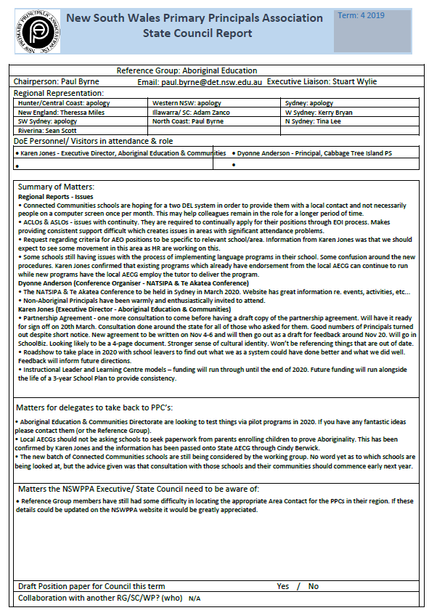

|  |  |
| --- | --- |
| **New South Wales Primary Principals Association**  **NSWPPA BadgeState Council Report** | Term:Four |

|  |
| --- |
| **Reference Group**:Assessment, Planning & Accountability |
| **Chairperson**: Scott Sanford **Email**: [scott.sanford@det.nsw.edu.au](mailto:scott.sanford@det.nsw.edu.au) **Executive Liaison**: Bob Willetts |
| Regional Representation:   |  |  |  | | --- | --- | --- | | Hunter/Central Coast: Leonie Clarkson | Western NSW: Scott Sanford | Sydney: Michelle Shelton | | New England: Charmaine Johnston (apology) | Illawarra/ SC: Glenn Daniels | W Sydney: Denise Hazell for Kerrie Beeby (apology) | | SW Sydney: Hamish Woudsma | North Coast: Narelle Kessey | N Sydney: Matthew Fuller | | Riverina: Jayne Gill |  |  |   DoE Personnel/ Visitors in attendance & role   |  |  | | --- | --- | | * Paul Wood – Director, Early Learning & Primary | * Daniel French - Relieving Director, NAPLAN Online | | * Dr Ahmed Deria - Director, High Performance | * Catherine Thompson - Director, Literacy & Numeracy |  |  | | --- | | Summary of Matters:  Issues received from members related to school planning, reporting to parents and online formative assessment tools.  **Early Learning & Primary:** Lots of support to pre-schools space to meet guidelines and legislation. Interim guidelines for Child Protection are out already. Partnership with the Catalyst Lab to start looking at reporting to parents. Two workshops with parents and teachers to be held in Term 4.  **SCOUT**: Enhancements continuing to occur within SCOUT.  **School Planning**: - The length of the new plan is still being determined as to whether it will be a 4 or 5 year plan. Planning for the new template is being finalised and will continued to be housed in SPaRO. It will be aligned to auto populate in the Annual Report. The Milestone tool will be more flexible. Leadership and High Performance are developing support and sample plans. A review of the School Excellence Policy will occur in 2020.  **School Improvement Curriculum Monitoring (SICM):** Completed for 2019. Looking to include support for the process in SPaRO.  **Literacy & Numeracy**: Literacy and Numeracy Intervention allocation continuing for 2020 – as currently shown in SBAR. There is a commitment to a new funding model for 2021. Pilot Phonics Check – will feed straight in to PLAN2 (similar to the way Best Start does) with diagnostic features. Schools will be able to nominate through EOI in Term 1. Implementation designed for Year 1 students in Term 3 and be available on demand. Professional Learning and support to accompany. CESE is currently conducting a review of L3 against research, best practice and considering the best models for schools. EaFS - resources that were once only accessible for EaFS schools through a portal are now available for all schools to access.. Phase 3 (future of EaFS) is a “watch this space”. | | Matters for delegates to take back to PPC’s:  **Early Learning & Primary:** Seven new scope and sequence plans for Science & Technology available online.  **SCOUT**: SSSG list in SCOUT are the 20 schools above and 20 schools below your FOEI. CESE Capacity Building Team looking to provide support for middle school leaders. There will be a focus on conducting effective evaluations, choosing the right data sources, identifyinh different evidence-based practices, etc. It will roll out over three years.  **Annual Report**: Automation of AR being finalised.  **School Registration 2020:** Random Inspections to focus on two strands, Strand A Child Protection and curriculum area of mathematics or PD/H/PE. Strand B will focus on HSIE. SICM will focus on HSIE.  **Literacy & Numeracy**: Helping Your Child with Literacy and Numeracy at School – new booklet - Will be in schools early next year to provide when reports issued or at Best Start (numbers based on enrolments). | | Matters the NSWPPA Executive/ State Council need to be aware of: Annual Report automation | | Draft Position paper for Council this term No | | Collaboration with another RG/SC/WP? (who) Curriculum RG for Interim Curriculum Review response. | |

