Berry Public School

# 

COVID-19

School Emergency Response Plan - Positive Result

# In the Plan:

Page 2: DoE Response Protocols snapshot (as per website)

Page 3: Evacuation Procedures

Page 4: Administration & Final Stage of Evacuation

Page 5: Staff List and responsibilities

Page 6: Evacuation Site Plan

Page 7: Example of Roll marking list.

Actions under the direction of Principal or Director

Positive COVID-19 Results DoE Response

* Communication with parents advising them whether their child has been in close contact with a confirmed case
* Media support
* Ceasing operations of the school (where it is deemed appropriate)
* Contact tracing to identify all close contacts to a confirmed case. In some instances, this may require ceasing the operations of the school while the contact tracing process is completed
* Thorough cleaning of the school site to ensure the environment is clean and safe prior to the school resuming onsite learning.

School Operations

* Parents/carers will be notified when a decision is made to cease school operations.
* To have the school site thoroughly cleaned.
* Information about the operational status ofthe school will be disseminated using the school's information channels, including the Schools Notification App, Facebook page and the department’s website.
* During this period, educational material will be made available through the department remote learning hub to enable students to continue learning at home.
* Parents and students will be notified by the department when the school is ready to resume onsite learning.

Contact tracing

* + Parents/carers will be notified via a phone call and formally in writing if their child has been in close contact with someone who has tested positive to COVID-19 while at school.
  + These students will be required to remain in home isolation and not return to school for 14 days from the last possible contact. In this situation, the school will arrange for the student to receive their learning programs at home.
  + Where a student is not deemed to be a close contact, parents will receive a letter advising them to monitor their child for symptoms and to seek treatment if appropriate. In these situations, students and staff are not required to self-isolate and can continue to attend school and engage in their normal activities within the community.
  + All families will receive a formal letter from the school to advise them what to do if they have been at school on a day when the confirmed case was considered to be infectious.

**School Evacuation Procedures**

There is NO URGENCY for this evacuation

1. Follow the standard evacuation procedures to get to the Evacuation Point (Back Oval, concrete cricket pitch)
2. **Exception** to the standard Evacuation procedures. All students are to pack up and take their belongings with them.
3. Call the roll and report any absentees and their last known location to your Stage Assistant Principal.
4. Remain with students for supervision purposes until the Principal or next in charge advises the next phase of evacuating the school.
5. The School Administration Officer is responsible for taking ALL class lists and pencils to the meeting area.
6. RFF Teacher, if on a class, is responsible for that class and the Teacher on release will assist in the assembling area.

# Next Phase of evacuation

1. Teachers have been assigned to specific gates. All gates have been assigned alphabetized surnames.
   * If a casual teacher is on class they are to continue with procedures as per the staff member they are replacing (Assistant Principals should check in they understand their duty).
2. Admin staff will have signs for teaching staff showing alphabet line location. Ie: A-C, K-M etc. A roll folder will be handed out to staff.
3. Staff move further up the field towards the hall with the signs. Kinder teachers will assist their classes to go to the correct line. Jess Snell will systematically ask each class to move to the appropriate Surname line.
4. Teachers assigned will need to mark the roll again to ensure they have the students listed and move any students in the wrong line to the appropriate line.
5. Prior to moving off to your designated gate teaching staff should discuss how they would like to distribute the students to parents. Eg: 1 staff is calling out students' names for parent to move forward while the other staff is ID checking.
6. If you have all students on the list in attendance and an executive has agreed for you to transfer to your gate you may begin the final stage of evacuation.

**Administration**

In your folder will be the allocated list along with the current day’s absences. Please cross any student who is not in attendance on the day so that you will have a clearer indication of what students you will have to disperse to parents.

Signs will be placed at the gates and the notifications sent out to parents will also advise of our Evacuation Plan and what gate location they will be collecting their children from.

Face masks will be supplied

Please have your phone

Any student remaining after a period of time will be bought back to sit on the bench seat located under the Kindergarten rooms and phone calls to parents will be made.

SLSO’s to stay with assigned student. If no student assigned, assist the Admin staff

An admin staff member will be in the office taking calls etc from parents

Bob will be in his office receiving/making calls to relevant DoE departments

# Final Stage of Evacuation

1. Once you are at your designated gate the main priority is to ascertain who the person is collecting the student. An ID check **MUST** be done and a tick next to that person. If someone other than the parent is collecting the student they will need to wait until we have verification from one of the parents who the authorised person is collecting the child.
   * Admin staff will be monitoring the phones and emails for these changes and will advise once we have been notified.
2. Once all students in your group have left with a parent could you go to another gate to see if they require more assistance.

# Staff Debrief

1. Staff to collect their belongings, lock classrooms and make their way safely home.
2. Zoom meeting to be scheduled, staff to check emails once they have made it safely home, this will occur approx. 45 minutes after all staff have left the school site.

Jess Snell – Coordinating the oval evacuation

Assistant Principals not needed to supervise students’ dispersal to be roaming to ensure staff are coping with the evacuation and to assist in any capacity required.

|  |  |  |  |
| --- | --- | --- | --- |
| Surnames | No of Families per gate | Staff Member | Staff Member |
| A – C | 36 | Hannah Boan | Sue McAuliffe |
| D – F | 27 | Ainsley Wearne | Ruth Pearson |
| G – J | 37 | Karen Kent | Di Hill / Keely Hallowell |
| K – M | 39 | Brooke Henning | Sue McIntosh /Peter Burney |
| N – Q | 25 | Adam Simpson | Katie Vearing |
| R – T | 34 | Heather Felton / Wendy Quinn / Kim Grivas | Simba Gibson |
| V – W | 17 | Carol Ingold | Brett Sutton |

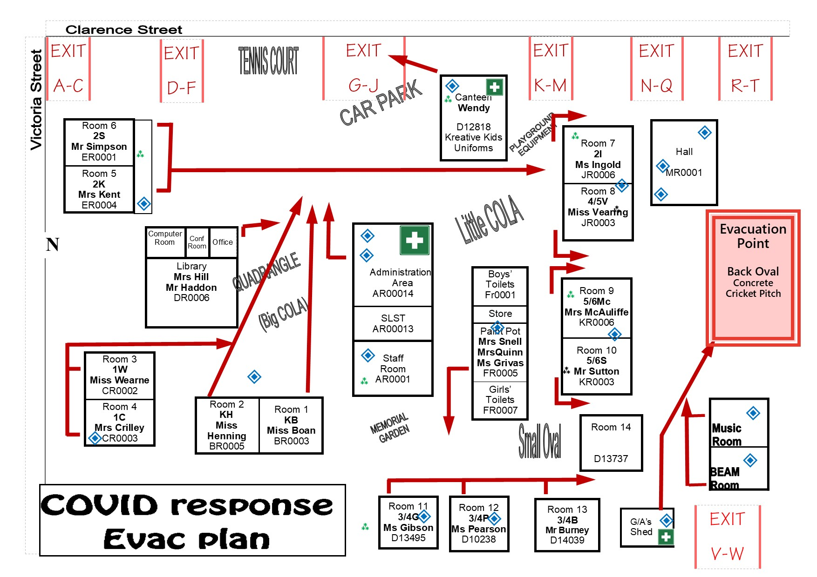

An example of list, all details will be included. Your duty is to check the first and second column. Both parents will be listed (if applicable) only tick the row as to which parent collects the student.

