**NSW Primary Principals’ Association Inc.**

**State Council Meeting**

**Term 1**

**11 and 12 March,2021, 2021**

**Council Kit**

**CORPORATE PARTNERS**





**BUSINESS PARTNERS**



# Contents

|  |
| --- |
| **Agenda State Council Term 1 2021 3** |
| **President’s Report State Council Term 1 2021 8** |
| **Treasurer’s Report State Council Term 1 2021 12** |
| **Minutes State Council Term 4 2020 14** |
| **Attendance Register State Council Term 4 2020 22**  **APPA 25**  **AGPPA 26**  **Appendix 1 - Balance Sheet Multi Period Sept- Dec 28**  **Appendix 2 – Profit and Loss Cash Sept-Dec 2020 29** |

***Thursday 11 and Friday 12 March 2021 Online Meeting***

[***Join Thursday’s State Council Zoom here***](https://nsweducation.zoom.us/j/63845650741?pwd=aWtvVC9IdTdhL2psSVdiWGhmTFZzZz09)

***Or copy and paste this link into your browser…***

<https://nsweducation.zoom.us/j/63845650741?pwd=aWtvVC9IdTdhL2psSVdiWGhmTFZzZz09>

***Area Council Delegates, Presidents, Reference Group/Standing Committee/Working Party Chairpersons, Observer Delegates and State Executive***

**AGENDA**

***Day 1 – Thursday 11 March 2021***

***(Sessions chaired by President, Robyn Evans, unless otherwise indicated)***

***8:30am – 9:00am (login available from 8:00am)***

1. **Commencement of Term 1 State Council Meeting**
   1. ***Welcome & online protocols reminder***
   2. ***Acknowledgement of Country***
2. **State Council Opening Business**
   1. ***Apologies***
   2. ***Introduction of new members***
   3. ***Stewart House – arrangements, members encouraged to join & promote salary contributions to Stewart House***
3. **Agenda**
   1. ***Items as circulated***
   2. ***Additional items and variations***
   3. ***Acceptance***
4. **President’s Report**

***President, Robyn Evans***

* 1. ***Report as circulated***

***9:00am – 9:45am***

1. **NSWPPA Priorities – Break Out rooms in use.**

***Chair: Deputy President Bob Willetts***

* 1. ***Presentation: Structure of Priorities***
  2. ***Explanation of break out room task***
  3. ***Move to break out rooms to complete task, each room will be assigned a single priority to focus on. (State Executive member in each room- To write on priorities document)***

***9:45am – 9:50am***

1. **Minutes of Term 4 2020 State Council Meeting**

***Secretary, Greg McLaren***

* 1. ***Presentation***
  2. ***Questions & Discussion***
  3. ***Acceptance***

***9:50am – 10:00am***

1. **Treasurer’s Report**

***Treasurer, Gregory Grinham***

* 1. ***Report as circulated***
  2. ***Highlighted items***
  3. ***Acceptance***

***10:00am – 10:30am Question Development – Break Out rooms in use***

1. **Question Development – Break Out rooms in use**

***Chair: Vice President Jude Hayman***

* 1. ***Explanation of how task will be completed***

***Move to 9 break out rooms to complete task (State Executive member in each room)***

* 1. ***Development of questions for session with***
     1. ***Group Deputy Secretary Georgina Harrisson***
     2. ***Daniel French-SIP Assessment, HIPL***
     3. ***Daryl Currie-Role of PSOs, Complaints Handling, Direct Management Action***
     4. ***Michelle Michael, Stephen Loquet, Mark Greentree-Rural Ed, TEAMS, Functionality***
     5. ***Minister Sarah Mitchell***
     6. ***Marnie O’Brien-COVID19 update on cross networks meetings***
     7. ***Deputy Secretaries Murat Dizdar & Leanne Nixon***
     8. ***Paul Wood-Curriculum reforms, Tools for practical in schools***
     9. ***Ruth Owen-Vision, First 100 days, Focus on Outcomes for students 10:30am – 11:00am Morning Tea***

***11:00am – 12:00 midday***

1. **Guest: Georgina Harrisson, Group Deputy Secretary**

***Chair: Vice President Michael Burgess***

* 1. ***Welcome***
  2. ***Presentation***
  3. ***Questions and Discussion*** ***12:00 midday –12:10pm Short Break***

***12:10 – 12:30***

1. **Panel Session 1: Reference Group/Standing Committee/Working Party Chairpersons**

***Chair: Deputy President Rob Walker***

* 1. ***Questions on reports (as previously tabled/circulated)***

***12:30- 1:00pm***

1. **Guest: Daniel French, Director School Excellence, Office of the Deputy Secretary, Educational Services**

***Chair: Treasurer Gregory Grinham***

* 1. ***Welcome***
  2. ***Presentation***
  3. ***Questions and Discussion***

***1:00pm –1:45pm Lunch*** ***1:45pm –2:30pm***

1. **Guest: Daryl Currie, Acting Executive Director, Professional and Ethical Standards Directorate (PES)**

***Chair: Secretary Greg McLaren***

* 1. ***Welcome 12.2Presentation***

***12.3 Questions and Discussion***

***2:30pm–3:00pm***

1. **Panel Session 2: Reference Group/Standing Committee/Working Party Chairpersons**

***Chair: Deputy President Rob Walker***

***Questions on reports (as previously tabled/circulated)***

***3:00pm – 3:10 Short Break*** ***3:10pm –3:40pm***

1. **PPA Business Session : What Works Well in PPCs?**

***Chair: Vice President Stuart Wylie & Vice President Gregory Grinham***

* 1. ***Explanation of break out room task***
  2. ***Move to break out rooms to complete task.***

***3:40pm Meeting Adjourned for Day One for all Delegates, Presidents, Chairpersons and Observers.*** ***3:40pm – 4:00pm Executive Reflection on Day 1 and refinements for Day 2.***

***Day 2 – Friday 12 March 2021 Online Meeting***

[***Join Friday’s State Council Zoom here***](https://nsweducation.zoom.us/j/61591515165?pwd=dHI3TjZ4QW1CZWZaKy82cW41Z3kyUT09)

***Or copy and paste this link into your browser…***

<https://nsweducation.zoom.us/j/61591515165?pwd=dHI3TjZ4QW1CZWZaKy82cW41Z3kyUT09>

**(Sessions chaired by President, Robyn Evans, unless otherwise indicated)**

***8:30am – 9:00am***

1. **Review of Day One and outline/update of sessions for Day 2**

***Chair: Secretary Greg McLaren***

1. **NSWPPA Business Session**
   1. ***APPA Report – President, Robyn Evans***
   2. ***AGPPA Report – Vice President, Michael Burgess***

***9:00am – 9:50am***

1. **Guests: Michelle Michael, Director, Learning Design and Development, Education Services** **Stephen Loquet, Chief Information Officer**

**Mark Greentree, Director, Technology For Learning, Teaching & Learning Experience**

***Chair: Vice President Michael Trist***

* 1. ***Welcome***
  2. ***Presentation***
  3. ***Questions and Discussion*** ***9:50am – 10:00am Short Break***

***10:00am – 10:30am***

1. **Guest: Minister for Education and Early Childhood Learning, the Hon Sarah Mitchell MLC**

***Chair: President Robyn Evans***

* 1. ***Welcome***
  2. ***Presentation***
  3. ***Questions and Discussion***

***10:30am – 11:00am***

1. **Guest: Marnie O’Brien, Executive Director, Health and Safety**

***Chair: Vice President Norma Petrocco***

* 1. ***Welcome***
  2. ***Presentation***
  3. ***Questions and Discussion*** ***11:00am - 11:30am Morning Tea***

***11:30am – 12:15pm***

1. **Guests: Murat Dizdar and Leanne Nixon, Deputy Secretaries, School Performance.**

***Chair: Vice President Stuart Wylie***

* 1. ***Welcome***
  2. ***Presentation***
  3. ***Questions and Discussion***

***12:15pm – 1:00pm***

1. **Guest: Paul Wood, Director, Early Learning and Primary Education, Learning and Teaching**

***Chair*: *Vice-President Trish Peters***

* 1. ***Welcome***
  2. ***Presentation***
  3. ***Questions and Discussion*** ***1:00pm - 1:30pm Lunch***

***1:30pm –2:00 pm***

1. **Guest: Ruth Owen, Deputy Secretary, Learning Improvement**

***Chair: Vice President Michael Burgess***

* 1. ***Welcome***
  2. ***Presentation***
  3. ***Questions and Discussion***

***2:00pm – 2:15pm***

1. **Professional Learning Officer’s Report**

***Professional Learning Officer Margaret Charlton***

***2:15pm –3:00pm***

1. **Panel Session 4: Reference Group/Standing Committee/Working Party Chairpersons**

***Chair: Deputy President, Rob Walker***

* 1. ***Questions on reports (as previously tabled/circulated)***

***3:00pm* Wrap up and scheduled closure of meeting**

***Chair: President Robyn Evans***

***Next Meeting***

***Term 2, 2021 NSWPPA State Council Meeting***

***Thursday 3 and Friday 4 June, 2021*** ***Novotel Sydney Central OR online!***

***Stay Safe, and Healthy***

President’s Report

Welcome to the Term 1 NSWPPA State Council Meeting - Week 7 and what a term this has been. YOU have harnessed everything that has come your way BRILLIANTLY. The cognitive load you are carrying however, is felt and acknowledged. The same commentary is being shared across the state with the Strategic Improvement Plan being due by the end of term AND everything else we have carriage of including the start of the school year, teaching, learning, community, students, staff and COVID 19 restrictions. It has however been brilliant with the ease of restrictions being able to reconnect with colleagues and make adjustments for face to face meetings. The excitement has been palpable. Thankyou everyone for the time and energy you have invested in keeping each other safe by adhering to point in time guidelines.

In terms of the SIP, DEL’s have been asking for progress updates many have been leveraging the support being provided by the PSL’s. When in the conversation with the DEL’s around the SIP rubric, I encourage you to reflect on the SCHOOL action and operationalising plans and discuss what further support you require from the system - a range of services and supports can be accessed at a Regional level including curriculum, wellbeing, leadership and financial support. These discussions triangulate the personnel and PL required to set the platform for potential success in achieving your school targets. PDP’s for Principals and Staff are goals set to personally grow in a sharp and narrow area to contribute to achieving the goals you set for your school. Your challenge is to narrow your focus and wrap the support you require around it to grow in that area. Following your meeting with your DEL discussion additional support that may be required we encourage you to send an email to your DEL so as a system we can ensure that we are authentically collaborating as a system to ensure we have accessed every possible resource to lift ALL students across the state and close the gap for our identified students. We can only achieve excellence when we as a system work in a partnership to achieve this goal.

We need the space to achieve the best outcome in teaching and learning. Support for Principals, Executive, Teachers, Support Staff and Administrators to do so. Our DEL’s ED’s PSL’s and Senior DoE Colleagues need to narrow the focus also *– WE CAN DO this together.*

***What WILL be taken off our desks so we can lead, teach and learn with clarity, support and focus?***

**Behaviour Strategy**

Significant consultation is taking place in this area with strong voices from the Associations leaders. Evidence based research has been presented and continues to be discussed. How the strategy lands in our schools and what it looks like continues to be a source of robust conversation. Association Executive both PPA and SPC are working to ensure students, staff, community, principals are supported to engage fully in teaching and learning.

## NSW Teachers Federation GALLOP Inquiry and Conference

Following the Gallop Inquiry at the NSW Teachers Federation Council Meeting, a group of us including Deputy Presidents Rob Walker, Bob Willets, Vice President Trish Peters and a number of our Primary Principal colleagues attended the NSWTF Conference. It is time to reset and focus on how we achieve the recommendations of the inquiry. The recommendations will be taken to both the Minister of Education

and Secretary at upcoming meetings. NSWTF President Angelo Gavrielatos and Dr Geoff Gallop continue their road trip across New South Wales over the next few weeks. The Gallop Inquiry highlights many issues that are familiar to us all.

## NSWPPA Priorities

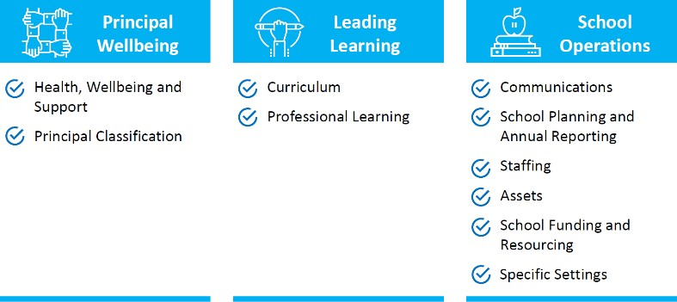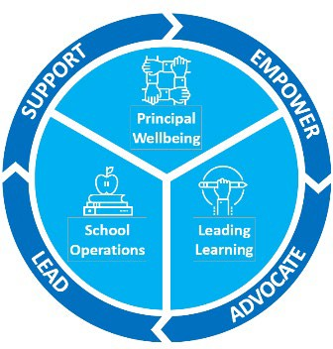The NSWPPA State Executive and chairpersons and delegates have contributed to the 2021|2022 Priorities and action forward. The Reference Groups, Standing Committees and Working Parties Chairs, Members and Liaisons will look at the proactive actions and responsive strategies to issues arising. Once finalised by the RG’s SC’s and WP’s, a working document of proactive strategies will be mile stoned to contribute to the aspirations and goals of the Association. The Association leads the voice of the membership. Your Primary Principal Council membership is key to the success of harnessing the voice of many, PPC Executives build communities of practice for the Delegates to gather the collective voice to the key initiatives, policies and practices the Department and Government shape for Public Education. It is the NSWPPA Executives role to Support, Empower, Advocate and Lead with the voice of 1800 Primary Principal members.

## Rural and Remote

**Strategy**

The NSWPPA Executive and Rural Education Standing Committee Chairperson and members have consulted widely and responded to the Rural and Remote Strategy. Many of voices have been sought to respond to this strategy – it is about attracting and retaining colleagues in rural regional and remote areas. These strategies are transferrable to all hard to staff contexts. Thank you to every Principal who has contributed. All Associations have been invited to contribute.

## Budget Estimates in the Macquarie Room

Many of you joined the online proceedings of the sitting of the Budget Estimates with the DoE Senior Leaders being pressed to respond to areas including:

* Infrastructure
* Workload
* Restructure
* Sexual Assault in Schools
* Wellbeing
* Premiers Priorities
* Gallop Inquiry

Much was addressed about individual sites and details – some which was taken on notice. It was apparent Government Parties are holding the DoE leaders accountable for delivering the commitments made politically as well as addressing business arising from individual sites and inquiries.

## Communication |What’s Hot |PPC Meetings | Send an Email |Call me

At a time when the strength we have is in a collective voice, I ask you to actively communicate with each other the NSW State Executive and myself.

In my time as a Principal, I have to say the workload and cognitive load we are currently experiencing has never been heavier. We must rely on each other and authentically support and leverage off one another. It must be said that the NSWPPA is not a political nor a union body. We are charged with the task of SUPPORTING | EMPOWERING | ADVOCATING and| LEADING *– Principals supporting, empowering, advocating and leading Principals*.

The strength of our voice in shaping the policies, practices and procedures that the Government and Department initiate relies on being in at the ground level to build it in partnerships of practice. Building strong and respectful relationships matters as does *ensuring it all lands in schools* with accuracy and support how can we ensure we have a sharp and narrow focus to ensure the initiatives are operationalised and supported to the fullest.

We need to keep pushing hard in the space of the Master Schedule and Consolidated Schedule - high quality professional learning, support and time are critical factors in supporting our staff to deliver in classrooms. A narrower focus is urgent.

I ask you open your emails to read What’s Hot in Week 3|6 and 9 each term. The NSWPPA State Executive and I will be offering the latest information and updates available at that point in time. Knowledge is key to ensuring we have your voice captured and expressed. Attending your PPC Meetings is a key component in supporting your wellbeing as well as hearing the absolute latest news and advice forward. Many PPC’s are offering hybrid meetings currently – colleagues are coming into meetings in person and others are coming in via zoom.

## Wellbeing

YOU MATTER. No one is more important than you. YOU are the leverage point for all members of your school community. Resting, recovering and recharging are key components of your energy levels and your ability to systematically achieve your daily goals and ‘to do lists ‘. Making time to laugh and celebrate needs to be locked in EVERYDAY – chase the moments you can authentically say ‘this is the reason I do my job ‘With the flux of ‘to do’s coming across our desks we can inadvertently miss the things we must prioritise and address – I am hearing the voice of the Principalship and acknowledge the workload has gone into overdrive. This week and next the NSWPPA Executive again have the opportunity to speak with the Minister and Secretary on this specific matter.

***What we have been involved in the past 7 weeks:***

* Behaviour Strategy
* Federation Meetings |APPA|AGPPA Meetings
* Reference Group| Standing Committee |Working Party Meetings
* Meeting with Sarah Mitchell Minister of Education | Mark Scott Secretary of NSW Education
* Meeting with Leanne Nixon
* Legal Services Meetings
* Anxiety Project
* Research Initiative to inform NSWPPA Position Papers
* Panel Representation
* Intensive PSL Support Model
* COVID 19 Updates | COVID Intensive Support Updates
* Meeting with Professional Support Officers
* Watching with interest at the Budget Estimates
* School Leadership Institute – Principal and Deputy Principals role description
* Sydney Morning Herald – Schools Summit
* Connected Communities Conversations and Panels
* Aboriginal Education and Communities Committee Meetings
* Leadership Pathways – NSWPPA Professional Learning Conversations
* Curriculum Reform Stakeholders Meetings
* Bushfire Strategy Meeting
* Finance and Administration – Carry Forward Policy
* School Visits
* State Executive Meetings |PPC Meetings |SPC Meetings… just to name a few
* 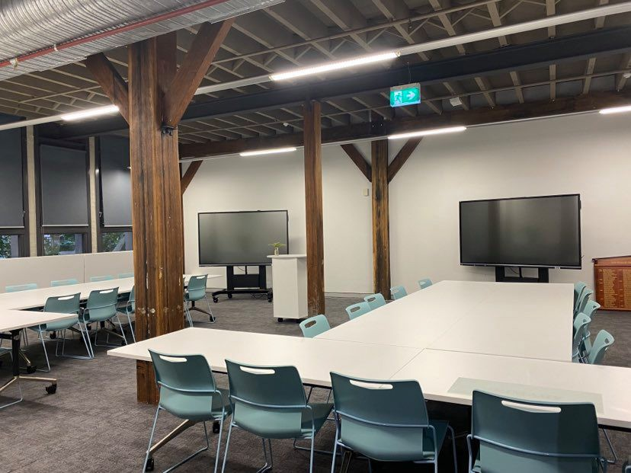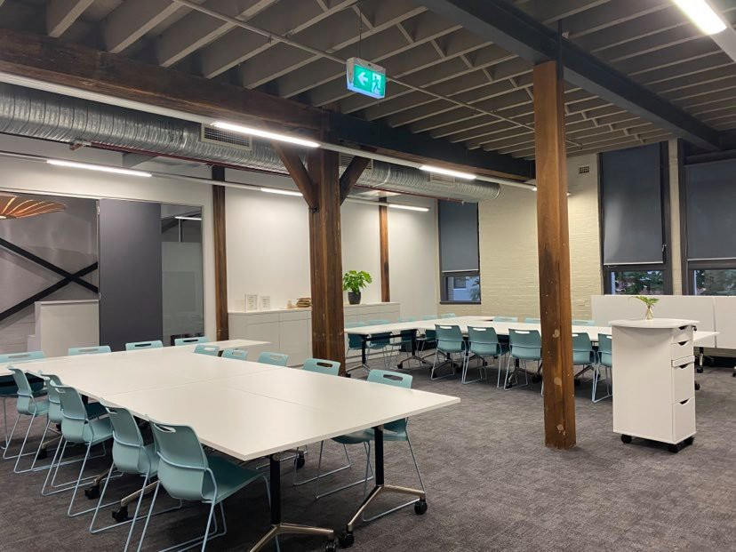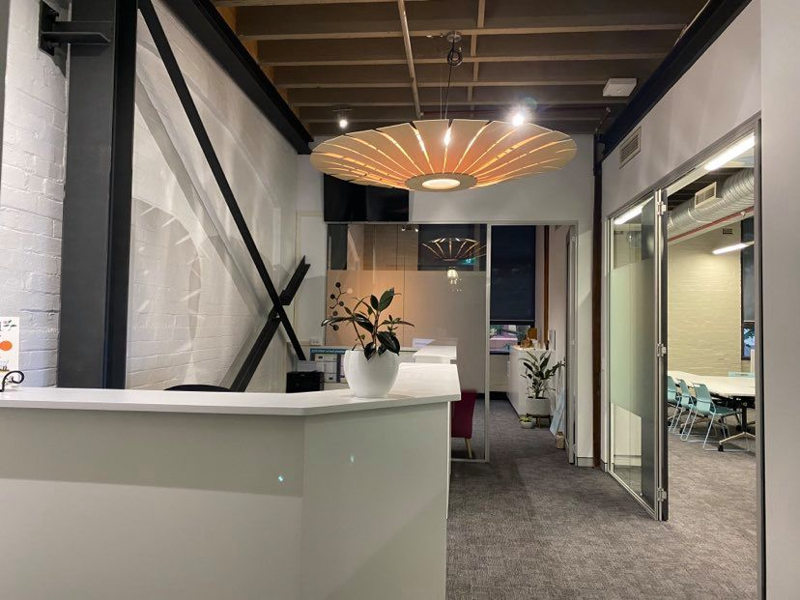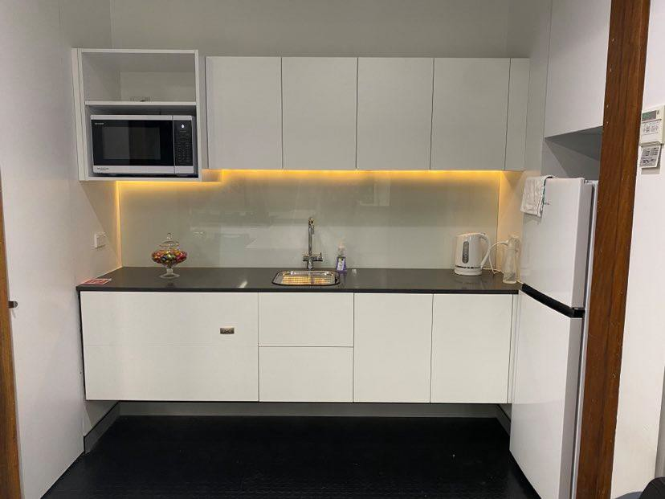And… creating the Professional Learning Centre and Offices for the NSWPPA… it is coming along and we are planning to be operational for term 2 2021.

## Robyn Evans

Term 1 2021 State Council Treasurer’s Report

Pleasure to present my first report for 2021 as State Treasurer, and I would like to thank **Michael Burgess** for his support and sage guidance during the handover period, and for assisting with the development of the report that I present to this State Council.

Th balances of the NSWPPA accounts on Thursday 4 March were:

|  |  |  |  |
| --- | --- | --- | --- |
| NAME | BSB | ACCOUNT NUMBER | ACCOUNT BALANCE |
| Business online | 062 900 | 1051 3465 | 826.45 |
| Conference | 062 262 | 1005 0470 | 18033.43 |
| General | 062 548 | 1020 2587 | 473623.36 |
| Professional Learning | 062 000 | 1933 5165 | 507.48 |
| Term Deposit | 062 649 | 5005 3981 | 0.00 |
|  |  | Total Credits: | $492990.72 |
|  |  | Net Position: | $536036.88 |

|  |
| --- |
| Notes: |
| **1:** We are still waiting for the Grant  to come through from Department of Education. Thank you to Michael Burgess and Mark Pritchard for completing the paperwork from  last year’s grant money. |

**2:** It seems that we are still

having concerns with our changeover of signatures. Thank you, Mark, for following up on these concerns with our bank.

Did I hear you ask, **'Which Bank?' 3:** The office fit out is continuing. Slowly taking shape.

I will have a full break-down against the proposed budget allocations for our next meeting.

**4:** Area Treasurers, I will be holding a zoom meeting with you on Tuesday 23 Mach, at 3:30PM. Please let me know if you will be unavailable.

* https://nswppa.schoolzineplus.com/form/7

## Gregory Grinham State Treasurer

Please note that all claims should come to me. Please inform your admin staff also. My contact details are: [Gregory.Grinham@det.nsw.edu.au](mailto:Gregory.Grinham@det.nsw.edu.au)

Granville Public School l Lena Street l GRANVILLE NSW 2142 02-9897 5712 (Direct Line) or 0422 670 860 (M)

## Relieving and Acting Principals

Relieving and Acting Principals who are in the role for an indefinite period should complete the salary deduction form and submit it to the email address on the bottom of the form.

Relieving and Acting Principals who are in the role for a known fixed period will have their membership payment calculated for this period based on $23.08 per fortnight. Membership is considered a personal expense (not school) and stays with the individual if they move schools. Once calculated, the payment should be made via direct deposit to the NSWPPA (account details below). Assistance in making the calculation may be obtained from either the State Treasurer or your Area Treasurer.

Account name: NSW Primary Principals Association BSB: 062 548

Account number: 1020 2587

Description: Membership <PPC joined> [assuming payment is from personal account]

***Please remind any relieving/acting Principals to cancel their salary deductions (by contacting EdConnect) once they have completed their role.***

Gregory (Greg) Grinham l Principal l Granville Public School l Lena Street l GRANVILLE NSW 2142 l 02-9897 5712 (Direct Line) l 0422 670 860 (M) l [gregory.grinham@det.nsw.edu.au](mailto:gregory.grinham@det.nsw.edu.au) l [ggrinham@nswppa.org.au](mailto:ggrinham@nswppa.org.au)

## Appendix 1- SCT 2021 Balance Sheet Sept-Dec 2020 Appendix 2- SCT1 2021 Profit and Loss Cash Sept-Dec 2020



|  |  |  |  |
| --- | --- | --- | --- |
| **NSWPPA TERM 4 2020 STATE COUNCIL MEETING**  **MINUTES** | |  |  |
| **DAY 1 – Thursday 26 November**  (Sessions chaired by President, Robyn Evans, unless otherwise indicated) | | | |
|  | | | |
| 8:30am | 1. **Commencement of Term 4 State Council Meeting**    1. Welcome & online protocols reminder   Please have videos and mute on and use the chat feature, two executives will be monitoring the chat and asking your questions   * 1. Acknowledgement of Country | | |
| 1. **State Council Opening Business**    1. Apologies: Karen Mortimer, Judy Goodsell, Peter Flannery, Tom Croker, Andrew McEachern, Gayle Pinn, Mark Diamond, Simon Mulready, Irene Faros, Simon Parson.    2. Introduction of new members to State Council:   Nichole Williams, Peter Craft, Richard Metcalf, Teresa Gosche, Unity Taylor-Hall, Michelle Collyer, Bronwyn Jeffree.   * 1. Stewart House – NSWPPA members encouraged to join & promote salary contributions to Stewart House at their school.      + $7560 was donated from NSWPPA from Dr Adam Fraser principal wellbeing event Keen to hear the voice of NSWPPA membership through State Council. | | |
| 1. **Agenda**    1. Items as circulated    2. Additional items and variations    3. Acceptance. Moved: Robyn Evans. Seconded: Michael Trist CARRIED | | |
| 1. **President’s Report, Robyn Evans**    1. Report as circulated       * PowerPoint presentation provided       * NSWPPA should be property owners by end of the day with the purchase of the new premises, Suites 1.04 & 1.05, 22-36 Mountain Street, Ultimo 2007.       * State Conference Committee congratulated for the successful transition to online delivery and ability to capture the high number of Principals attendees. Special mention was extended to Principals, Kylie Donovan (chair), Karen DeFalco and Cameron Upcroft as well as Executive Officer, Mark Pritchard and Executive Liaison, Rob Walker.       * Dr Adam Fraser led Recovery Workshop proved valuable. Livestreams are proposed for 2021 on various topics.       * NSWPPA was admirably represented at NSW Parliamentary Inquiry by Deputy President, Bob Willetts and Vice President, Norma Petrocco.       * Referred to NSWPPA and Deputy Secretaries emails about distancing at PPC AGMs. Limit of twenty Principals from same network meeting in the same venue. Due to this restriction PPCs are also encouraged to reach out to ‘isolated’ Principals.       * NSWPPA priority is to look at best practice with communication in and out of the   Association. Engaging PPA Communication and Engagement SC chair, David Munday. | | |

|  |  |
| --- | --- |
|  | * Encouraged PPCs to forwards details to PPA Executive Assistant, Lisa Beare, [lbeare@nswppa.org.au](mailto:lbeare@nswppa.org.au) , AGM election outcomes and 2021 meeting dates. Include names of ten Principals for merit selection panels. * Acknowledged the effort of Principals during COVID-19 especially looking after students and staff. * Wished all non-returning members of State Council the very best and thanked them for their contribution.   4.2 Acceptance. Moved: Robyn Evans. Seconded: Michael Burgess CARRIED |
| 9.00am | 1. **Minutes of Term 3 2020 State Council Meeting, Secretary, Greg McLaren**    1. Presentation    2. Questions & Discussion       * No questions nor amendments to the term 3 minutes.    3. Acceptance. Moved: Rob Walker. Seconded: Bob Willetts CARRIED |
| 9.05am | 1. **Treasurer’s Report, Gregory Grinham**    1. Report as circulated       * PowerPoint presentation provided    2. Highlighted items    3. Acceptance. Moved: Gregory Grinham. Seconded: Norma Petrocco CARRIED |
| 9.15am | 1. **Question Development – Break Out rooms in use**    1. Explanation of how task will be completed    2. Move to break out rooms to complete task (State Executive member in each room)    3. Development of questions for session with       1. Group Deputy Secretary, Georgina Harrisson       2. The Hon Sarah Mitchell MLC, Minister for Education       3. Secretary, Mark Scott       4. Deputy Secretaries, Murat Dizdar & Cathy Brennan       5. a/Deputy Secretary, Jane Simmons       6. a/Chief People Officer, Lisa Alonso Love       7. Chief Finance Officer – Gerard Giesekam, Director, Finance Excellence - Vanessa Felton and Manager, Finance - Jessica Horn   *Chair, Vice-President, Stuart Wylie* |
| 9.45am | Break |
| 9.55am | 1. **Guest: Georgina Harrisson, Group Deputy Secretary**    1. Welcome    2. Presentation       * Group Deputy Secretary acknowledged the "exhaustion" of Principals, which is due to the combination of "change fatigue", "decision fatigue" and "compassion fatigue”.       * Further acknowledged all Principals for our response to COVID-19 throughout 2020. Returned to the topic later by stating her confidence in the system’s ability to work on challenges such as the COVID-19 learning from home experience.       * Announced how valuable this year were the Phonics Check and Check-In data and is aware of support from schools for the tests.       * Undertaking an “improvement with transparency in the organisation” by “looking at   what matters most” and “shift towards clarity” with all working in the “same direction”. |

|  |  |
| --- | --- |
|  | * Mentioned there needs to be more accountability in the organisation to better support Principals. This will require “more to be expected from support directorates”. * Reminded Principals of six terms lefts on Premier’s Priority. This will place “increased pressure on education standards”. * 2021 having “big expectations from senior executive for improved student outcomes”. * Suggested the DoE belief is that we do not need Teaching Australia program.   1. Questions and Discussion      + Question about disconnect with DoE senior executive due to not having education background. The response was that most DELs have a Principal background and most DELs have taught in the DoE. Response was not extended to other senior officers.   Question asked about an external validation for directorates. It was acknowledged the value in the learning organisation but was not well received by the DoE to extend outside of schools. Group Deputy Secretary mentioned she has targets for her review by the Secretary.  *Chair, Vice President, Trish Peters* |
| 10.45am | **9 Panel Session 1: Reference Group/Standing Committee/Working Party Chairpersons** Questions on reports (as previously tabled/circulated in Term 4 State Council Reports document)  *Chair: Deputy President, Rob Walker* |
| 11.00am | Morning Tea |
| 11.30am | 1. **Panel Session 2: Reference Group/Standing Committee/Working Party Chairpersons**    1. Questions on reports (as previously tabled/circulated in Term 4 State Council Reports document)   *Chair: Deputy President, Rob Walker* |
| 11.55am | **11 Workshop: PPA Objectives SWOT Analysis – Break Out rooms in use**  *Chair: Deputy President, Bob Willetts* |
| 1.00pm | Lunch |
| 1.30pm | 1. **Guest: Minister for Education and Early Childhood Learning, the Hon Sarah Mitchell MLC**    1. Welcome    2. Presentation       * Noted the budget was announced in November rather than June due to COVID-19. Minister suggested it was fair to education especially with infrastructure funding.       * Renewal program for rural and metro offering $240 million for projects to “upgrade items on schools wish lists” such as COLAs and toilets. Anticipated 600 rural and 100 metro schools to benefit.       * Drought relief package in place until 2023.       * 700 schools to benefit from LED light pilot. Schools without too much recent attention will be the recipient schools.       * Tuition program offering $330 million access for support in classrooms for students. A twelve months program with 8,000 expressions of interest to date. It will be flexible with delivery to various cohorts. Desire is to recruit retired school leaders and other teachers.       * Nurses in primary schools project still requires discussion with Health NSW.       * Rollout of rural package, pilot around 25 schools in the Dubbo area. Ten parts to the package. Improved IT for schools with each teacher having an IT device, upgrade of   technology in classrooms and 1:4 IT device/student ratio for rural students.   * + - Data indicates inequity between metro and rural schools. |

|  |  |
| --- | --- |
|  | * Minister anticipates updated COVID 19 guidelines for commencement of term 1, to see more pre COVID conditions.   1. Questions and Discussion      + Commitment not to use “minimum standards people” to do Teaching Australia program. Desire is to recruit mid-career people to then attain appropriate teacher training.   *Chair: President, Robyn Evans* |
|  | 1. **Guest: Mark Scott, Secretary, Department of Education**    1. Welcome    2. Presentation       * Discussions with Health NSW prior to return for term 1, 2021 should move closer to business as usually with school excursions and parent access to schools.       * More COVID guidelines will be distributed in week 8, term 4, 2020.       * Secretary acknowledged the difficult year and how Principals must be tired.       * Two schools affected by bushfire during the last season.       * More money arrived to the organisation targeting education to “deal with the COVID disruption” and to “stimulate the economy”.       * Wellbeing on primary students “needs to be in DoE sights”.       * Tuition money comes with “expectation to keep going”.       * Check-in Assessment worked in the absence of NAPLaN. Speed of results and reliance on diagnostic proved a popular option.       * Recent restructure of DoE now places clear and accountability of senior executive. “The positions are to share accountability for achievement in schools.” New recruits to DoE were mentioned.       * “Every student known, valued and care for” stressed.       * $7.1 billion for capital works underway.       * Secretary passed on the Premier’s thanks to all in education for our work.    3. Questions and Discussion       * Response to question about a designated Rural & Remote Education Director solely looking after that role was met with a response that not all could be achieved with new DoE restructure.   *Chair: Secretary, Greg McLaren* |
| 3.00pm | 1. **Panel Session 3: Reference Group/Standing Committee/Working Party Chairpersons**    1. Questions on reports (as previously tabled/circulated in Term 4 State Council Reports document)   *Chair: Deputy President, Rob Walker* |
| 3.45pm | Meeting Adjourned for Day One for all Delegates, Chairpersons and Observers. |
| 3.45pm | Executive Reflection on Day 1 and refinements for Day 2. |
|  | |



|  |  |  |  |
| --- | --- | --- | --- |
|  | | **NSWPPA TERM 4 2020 STATE COUNCIL MEETING**  **MINUTES** |  |
|  | | | |
| **DAY 2 – Friday 27 November**  (Sessions chaired by President, Robyn Evans, unless otherwise indicated) | | | |
|  | | | |
| 8.30am | 1. **Review of Day One and outline/update of sessions for Day 2**    1. Acknowledgement of Country by President, Robyn Evans   *Chair: Secretary, Greg McLaren* | | |
| 1. **NSWPPA Business Session**    1. APPA Report – President, Robyn Evans (as previously tabled/circulated in Term 4 State Council Reports document)    2. AGPPA Report – President, Robyn Evans (as previously tabled/circulated in Term 4 State Council Reports document)       * 2021 AGPPA reps: Michael Burgess, Vice President, and Robyn Evans, President. | | |
| **2 Observer Group Reports**  Questions on reports (as previously tabled/circulated in Term 4 State Council Reports document)   * 1. Central schools   2. Environmental Education Centres   3. Principal School Leadership   4. Professional Support Officers   5. PSSA   6. Retired Principals   *Chair: Deputy President, Rob Walker* | | |
| 9.00am | **4 Guests: Murat Dizdar, Deputy Secretary School Performance, and Cathy Brennan, A/Deputy Secretary, School Performance**   * PowerPoint presentation provided * Areas of Consolidated Schools Schedule for Term 1, 2021 include: Behaviour Strategy; High Potential & Gifted Policy and resources; High Impact Professional Learning, Core Professional Learning; Revised Professional Learning Policy; Priority learning and school time reflection tool; FMO –Carry Forward (Finance) Policy; Principal & DP Role Description and School Leadership Policy; Implementation of new SASS training; Implementation of new SASS agreement (2021-2024); New School Counselling Service Professional Practice Framework; & New SchoolBiz. * School Excellence in Action a priority for schools. Dep Secretaries stressed to invest in professional learning and become very familiar with ‘What Works Best’ resources. * Two Staff Development Days for commencement of term1, 2021. Packages will be available of prerecorded information optional for Principals to use at SDD on topic AECG partnership agreement and school success model. No livestream is scheduled for SDD. * COVID Intensive Learning Support program will offer $307 million to government | | |

|  |  |
| --- | --- |
|  | schools. It is to improve the quality delivery of learning for students in need. |
| 9.45am | Break |
| 9.55am | **5 Presentation: Celebrations of our achievements against our Priorities**   * Each NSWPPA Reference Group and Standing Committee chair highlighted two significant areas of contribution to NSWPPA and public education.   *Chair: Deputy President, Rob Walker* |
| 10.15am | 1. **Guest: Jane Simmons PSM, A/Deputy Secretary Learning Improvement**    1. Welcome    2. Presentation       * Stressed that two different aspects of the Behaviour Strategy. The Behaviour Strategy and then its Policy. A/Dep Secretary acknowledged the NSWPPA representation from Vice President, Trish Peters and chair of Student Wellbeing RG, Helen Craigie. Although launched day 1 term 1, 2021 the procedures will be released in term 3.       * Mentioned the recent media notification of nurses in schools. A/Dep Secretary stressed the right people will be appointed in that role.       * Acknowledged the Access Request process has never been consistent in the State, even within the same performance directorate. Looking at aligning procedures in 2021. Noted that process of Access Request and panels are complicated. Communication of panel outcome will become the responsibility of the Principal as per what parents have indicated as important to them.       * A/Dep Secretary said farewell stating she cannot see her new DOE role having any direct relevance to NSWPPA as Executive Director, Skills and Higher Education.    3. Questions and Discussion       * Questions and comments were made by Principals about circumstance where Principals should not inform families of placement panel outcomes.   *Chair: Vice President, Norma Petrocco* |
| 11.00am | Morning Tea |
| 11.30am | 1. **Guest: Lisa Alonso Love, Acting Chief People Officer**    1. Welcome    2. Presentation       * PowerPoint presentation provided       * Acting Chief People Officer, indicated it was her last day in the role before moving to another job-sharing senior role in the DoE as Deputy Secretary, Education and Skills Reform again with Chloe Read.       * Identified two purposes of Human Resources directorate, School Workforce team looking after school personnel and People & Culture team overseeing corporate personnel.       * New Health & Safety directorate model aligned to operational directorates.       * Human Capital Management (HCM) to be repurposed.       * Staffing Methodology Review continuing to consider SSP supplementary funding entitlement.       * To be released soon, SASS Award resource support for implementation for day 1, term 1, 2021.    3. Questions and Discussion       * NSWPPA stressed the support for HCM and the breadth the unit collected information from Principals. |

|  |  |
| --- | --- |
|  | * Acting Chief People Officer indicated she had not seen the NSWPPA Principal Classification submission. Suggested her job sharer may have seen it but has yet to respond to NSWPPA.   Indicated that work engaging with Award parties is underway. NSWPPA will be consulted.   * Acting Chief People Officer said she has not seen the information about the Rural & Remote teacher shortage. Indicated taking the question on notice for a response to NSWPPA. Indicated that a general teacher supply discussion paper to be issued shortly.   *Chair: Vice-President, Michael Trist* |
| 12.15pm | **8 Area Council Issues**   * Griffith PPC issue relating to school staff required to take sick leave whilst working from home corporate staff do not need to utilise that leave entitlement. Issue referred to PPA Human Resources Reference Group for a response.   *Chair: Vice President, Michael Burgess* |
| 12.20pm | 1. **Workshop: 2021 Priorities formation – Break Out rooms in use**    1. Explanation of how task will be completed and State Executive appreciating the input to be further discussed at next State Executive meeting. Reported back to State Council in 2021.    2. Move to break out rooms to complete task (RG/SC Chair in each room leading)   *Chairs: Deputy Presidents, Rob Walker & Bob Willetts* |
| 1.00pm | Lunch |
| 1.30pm | 1. **Professional Learning Officer’s Report**    1. Professional Learning Officer Margaret Charlton    2. Presentation       * PowerPoint presentation provided       * Professional Learning Officer, Margaret Charlton, identified programs for leadership development offered through the NSWPPA: Credentials program; Flourish program; Seven Habits of Highly Effective People; Leading at the Speed of Trust; Art of Leadership; Middle Leadership Imperative for APs; Challenging Conversations.    3. Questions on reports (as previously tabled/circulated in Term 4 State Council Reports document)   *Chair: Deputy President, Rob Walker* |
| 1.45pm | 1. **Guests: Gerard Giesekam, Chief Finance Officer with Vanessa Felton Director Finance Excellence, Jess Horn, Manager Finance**    1. Welcome    2. Presentation       * PowerPoint presentation provided       * Explained the Carry Froward Policy relating to 6100 in consolidated funding. Funding to improve learning outcomes for students. Not relevant to 6300 School & Community funds which will remain separate.       * Reminder that finance coaching and support is available to Principals.       * Two components to Carry Froward Policy:   -Part one: opening balance from 2021 – under new 6101 with four years to spend.  Unused funds after four years will be centralised.  -Part two: ongoing unspent 6100 will not rollover. These funds need to be spent each year. A carry forward request can be made to your DEL will be required for unspent funds, for example, a school can apply for a photocopier using this policy. |

|  |  |
| --- | --- |
|  | * Carry Forward Policy will be reviewed annually to ensure alignment with DoE priorities.   1. Questions and Discussion      + Question were placed on noticed to be answered by Chief Finance Officer.   *Chair: Vice President, Michael Burgess* |
| 2.15pm | Wrap up and scheduled closure of meeting - President, Robyn Evans |
|  |  |
|  | |

**STATE COUNCIL TERM FOUR 2020 ATTENDANCE**

|  |  |  |  |  |
| --- | --- | --- | --- | --- |
| **STATE EXECUTIVE** | **EXECUTIVE Day One** | | **EXECUTIVE Day Two** | |
| PRESIDENT | Robyn Evans | | Robyn Evans | |
| DEPUTY PRESIDENT | Rob Walker | | Rob Walker | |
| DEPUTY PRESIDENT | Bob Willette | | Bob Willetts | |
| VICE PRESIDENT | Michael Burgess | | Michael Burgess | |
| VICE PRESIDENT | Jude Hayman | | Jude Hayman | |
| VICE PRESIDENT | Trish Peters | | Trish Peters | |
| VICE PRESIDENT | Norma Petrocco | | Norma Petrocco | |
| VICE PRESIDENT | Michael Trist | | Michael Trist | |
| VICE PRESIDENT | Stuart Wylie | | Stuart Wylie | |
| SECRETARY | Greg McLaren | | Greg McLaren | |
| TREASURER | Gregory Grinham | | Gregory Grinham | |
| EXECUTIVE OFFICER | Mark Pritchard | | Mark Pritchard | |
| PROFESSIONAL SUPPORT  OFFICER | Geoff Scott | | Geoff Scott | |
| PROFESSIONAL SUPPORT  OFFICER | Apology | | Wendy Buckley | |
| PROFESSIONAL SUPPORT  OFFICER | Phil Seymour | | Phil Seymour | |
| PROFESSIONAL SUPPORT  OFFICER | Margaret Charlton | | Margaret Charlton | |
|  | | | | |
| **REFERENCE GROUPS** | | **CHAIRPERSON**  **Day 1** | | **CHAIRPERSON**  **Day 2** |
| ABORIGINAL EDUCATION | | Paul Byrne | | Paul Byrne |
| ASSET MANAGEMENT | | Brent Kunkler | | Brent Kunkler |
| CURRICULUM | | Apology | | Apology |
| DISABILITY PROGRAMS | | Graeme McLeod | | Graeme McLeod |
| ASSESSMENT, PLANNING &  ACCOUNTABILITY | | Scott Sanford | | Scott Sanford |
| FINANCE & ADMINISTRATION | | Apology | | Apology |
| HUMAN RESOURCES | | Skye Seymour | | Skye Seymour |
| PRINCIPALS' SUPPORT | | Grace Palamara | | Grace Palamara |
| SCHOOLS SPECIFIC PURPOSE | | Mark Gosbell | | Apology |

|  |  |  |
| --- | --- | --- |
| STUDENT WELLBEING | Helen Craigie | Helen Craigie |
| **STANDING COMMITTEES** |  |  |
| ANNUAL CONFERENCE | Kylie Donovan | Kylie Donovan |
| COMMUNICATION and ENGAGEMENT | David Munday | David Munday |
| LEADERSHIP | Cath Larkman | Cath Larkman |
| LEGAL ISSUES | Apology | Apology |
| RURAL EDUCATION | Apology | Apology |
|  |  |  |
| **WORKING PARTY** |  |  |
| SCHOOL VIABILITY | Grant Schaefer | Grant Schaefer |
|  |  |  |
| **OBSERVER GROUPS** |  |  |
| CENTRAL SCHOOLS | Michael Windred | Michael Windred |
| ENVIRONMENTAL ED. CENTRES | Christine Freeman | Christine Freeman |
| PRINCIPAL SCHOOL LEADERSHIP | Carolyn Nugent | Carolyn Nugent |
| RETIRED PRINCIPALS | Tom Croker | Apology |
| PSSA | Andrew Hooper | Andrew Hooper |
|  |  |  |
|  |  |  |

|  |  |  |
| --- | --- | --- |
| **AREA COUNCILS** | **DELEGATE**  **Day One** | **DELEGATE**  **Day Two** |
| ALBURY | Nichole Williams | Brett Davies |
| ARMIDALE | Debbie Baker | Denise Smoother |
| BANKSTOWN | Ben Walsh | Ben Walsh |
| BATEMANS BAY | Carolyn Nugent | Carolyn Nugent |
| BATHURST | Jaime Medbury | Jaime Medbury |
| BLACKTOWN | Tracy Anderson | Tracy Anderson |
| BONDI | Craig Nielsen | Craig Nielsen |
| BOURKE | Angela Lewis | Lisa Wright |
| BROKEN HILL | Apology | Trish Webb |
| CAMPBELLTOWN | Dawn Dallas | Dawn Dallas |
| CENTRAL COAST | Leonie Clarkson | Leonie Clarkson |
| DENILIQUIN | Peter Craft | Peter Craft |
| DUBBO | Sharon Murray | Sharon Murray |
| FAIRFIELD | Genelle Petruszenko | Genelle Petruszenko |
| GRANVILLE | Estelle Southall | Apology |

|  |  |  |
| --- | --- | --- |
| GRIFFITH | Monica St Baker | Monica St Baker |
|  |  |  |
|  |  |  |
| HAWKESBURY/WINDSOR | Melanie Mackie | Melanie Mackie |
| HORNSBY | Milly Stone | Milly Stone |
| LAKE MACQUARIE | Richard Metcalf | Richard Metcalf |
| LISMORE | Shane Fletcher | Shane Fletcher |
| LIVERPOOL | Teresa Gosche | Teresa Gosche |
| MAITLAND | Kevin Greaves | Kevin Greaves |
| MID NORTH COAST | Robyn Urquhart | Robyn Urquhart |
| MOREE | Dan van Velthuizen | Kathryn Weston |
| MTDRUITT/MINCHINBURY | Belinda Davies | Belinda Davies |
| NEWCASTLE | Graham Finch | Graham Finch |
| NORTHERN BEACHES | Christine Smith | Christine Smith |
| ORANGE/LACHLAN | Steve McAlister | Steve McAlister |
| PARRAMATTA | Tony D’Amore | Tony D’Amore |
| PENRITH/BLUE MOUNTAINS | Andrew Hooper | Andrew Hooper |
| PORT JACKSON | Samantha Nicol | Samantha Nicol |
| PORT MACQUARIE | Jock Garven | Apology |
| QUEANBEYAN | Phil Katen | Phil Katen |
| RYDE | Unity Taylor-Hall | Michelle Collyer |
| SHELLHARBOUR | John Bond | John Bond |
| ST GEORGE | Michelle Shelton | Michelle Shelton |
| SUTHERLAND | Jason Ezzy | Jason Ezzy |
| TAMWORTH | Benjamin Carter | Benjamin Carter |
| TAREE | Deborah Scanes | Deborah Scanes |
| TWEED/BALLINA | Judi Albans | Judi Albans |
| UPPER HUNTER | Deborah Fisher | Narelle Hunt |
| WAGGA WAGGA | Kerry Barker | Kerry Barker |
| WOLLONGONG | Tim Fisher | Bronwyn Jeffree |



**This term the APPA Meetings are being held in three sessions VIA ZOOM on three separate dates.**

***Wednesday 24 February 2021***

**David DeCarvalho | ACARA**

Platform utilisation and scope of work including the NAPLAN work being done by Janet Davey. Technology discussion to ensure accessibility for all students, Confirmation that the review has ‘listened’ and acted on the voice of Principals and Teachers.

## BTS SPARK | Coaching Program

Twenty-eight leadership coaches across Australia available for individualised and group coaching. Malcolm Elliott President APPA undertaking – sharing from State and Territory Presidents. The course is designed to unlock natural leadership potential. It is about a shift in mindset – developing a sharp and narrow focus on what matters using a strategic framework.

## Media |SchoolTV

In association with APPA, SchoolTV is pleased to offer this important Special Report for your school community. ‘The recent allegations of sexual assault covered in the media, has sparked an online petition instigated by a former student from a private girl’s school in the eastern suburbs of Sydney. The petition asked for former students who had experienced sexual assault whilst still at school to come forward and share their stories. The petition has since gone viral with an enormous response from thousands of young women who have either signed the petition or shared their experience.

The accounts shared by these young women are disturbing, shocking, graphic and upsetting. It has set in motion a wake-up call for many schools to reassess their curriculum around sex and life education. The clear message arising from this is that education around consent is being delivered too late, with many young women being subjected to sexual assault before they reach Year 10. The petition is calling for change to help protect young people across the nation.

This also highlights a strong need for parents to step-up and start having conversations around consent. It is not enough to assume that your teenager knows or understands what it means and the implications surrounding it. Teenagers need to learn about boundaries, enabling them to respect themselves and their partners. Talking about consent regularly will help normalise it and encourage your teenager to experience healthy relationships as they journey into adulthood’.

For more information visit here: [www.schooltv.me](http://www.schooltv.me/)

***Tuesday 2 March 2021***

* + AGM
  + Business Meetings AGPPA|ACPPA | IPSHA| NATSIPA | AESEPA
  + NAC Audit discussed

*TRANS TASMAN CONFERENCE* | Australian Primary Principals Association and New Zealand Principals Federation - 20 -23 July 2021 Melbourne Convention Exhibition Centre <https://www.appa-nzpf2021.com/registration>

***Tuesday 9 March 2021***

* + Principals Australia Research Foundation: PARF – Dennis Yarrington
  + Survey Results - Impact on 2020 Primary Aged Students – Brett Comer and James Rusmir
  + Leading Australian Schools during COVID 19 Pandemic – Pivot Professional Learning |Amanda Bickerstaff CEO

*Report to be presented at Term 1 NSWPPA State Council Meeting: Robyn Evans NSWPPA President*



NSWPPA Representatives on the Australia Government Primary Principals Association are Robyn Evans and Michael Burgess.

**New Minister** – Alan Tudge Minister for Education and Youth – has been on the board of Teach Australia and Boston Consulting.

President has made initial contact. Hope to meet in the near future. New minister likes evidence and data

**AGM** – AGM held. Only one election of a vacant vice president role. Other office bearers are on a two year cycle.

**President has met with a number of other bodies** – including parent organisations, ACARA. Discussions around shifting NAPLAN year levels and introducing Y1 NAPLAN

**Future Leaders Pilot** – Department of Education, Skills and Employment working with Teach Australia. Project to test an approach to strengthening the school leadership pipeline for rural and remote schools. High achieving teachers with leadership potential. Not a Principal preparation program, leadership development.

Queensland first, followed by NSW. Victoria misses out as it doesn’t have any schools that meet the ‘remote’ criteria.

**Occupational Mobility** – Australian government taskforce looking at how to remove red tape to allow people to transfer between states in jobs. Submission from AGPPA particularly around registration processes to allow teachers to move seamlessly between states.

**Australia Department of Education meeting**

* + National schools resourcing for 2021 – PS $12099 (44%) and HS $15204 (56%). Push to have primary schools funded at the same level as secondary schools.
  + Regional and remote issues
  + National Curriculum update – a few hiccups will be released together soon.
  + NAPLAN review – teachable within the time available – suggestion 30 weeks’ worth of work over 40 weeks
  + Future leaders (as previously mentioned)

**AGPPA Strategic Plan** – time spent updating plan in small teams. Initial planning of actions from the plan. **Executive Officer** – AGPPA is going to appoint an executive officer as an interim step before the President is released full time. Once the President is released the need for an EO will diminish.

**Phil Riley Report 2020**

Released on 14th March. Press releases to be co-ordinated with national and state bodies. Time spent with Jo Stone (media consultant) to plan response strategy.

2020 report impacted by COVID conditions but at the same time no statistically significant difference in data. The effects may show up in future reports.

‘Everything changed but everything stayed the same’

Work was different but the stresses and pressures were the same. Less levels of offensive behaviour but stress the same.

Running a school in a system full of systemic stupidity that doesn’t trust or support you doesn’t change due to COVID.

Cracks became chasms especially in regards to equity issues. Learning going online challenging for under resourced schools.

The ‘more you care the more likely you burn out’ was a factor.

Black Saturday report in Victoria shows it has taken 10 years for students entering kindergarten to be back to the same levels as pre-bushfire.

Teachers reported ‘parent scrutiny stress’ Parents standing off camera monitoring home learning. COVID seemed to have more impact on the work of teachers as the work and context was very different.

Anecdotal evidence that social capital of the profession grown – parents realising the work involve din teaching. Not as easy as it seems.

The ‘person’ above seems to have a great deal of impact on the survey results in terms of stress and burnout.

Discussion around preparing leaders for the ‘tough’ bits. Don’t get to practice those skills until you are in the role. Influence Universities to include this in training.

Phil involved in a NT trial training people to deal with difficulty to see if that has an impact of health and safety. Phil not delivering but evaluating impact.

Suggestion that we need to do a cost/benefit analysis on the impact highlighted in the report. If DoE did something about the issues what is the cost saving to the budget? (of Health and Education)

Discussion of how COVID has changed the role – what didn’t we do that we can keep not doing, what did we do that we need to keep doing etc.

Parent presence versus parental engagement. When we let parents back in do we change how we engage with them?

Created: 7/03/2021 10:29 PM

**Balance Sheet [Multi-Period]**

September 2019 To December 2019

NSW Primary Principals Association Inc

Po Box 810 Surry Hills NSW 2010

ABN: 77 527 522 968

Email: [mark.pritchard@det.nsw.edu.au](mailto:mark.pritchard@det.nsw.edu.au)

**September October November December Adjustment Only**

Assets

|  |  |  |  |  |  |
| --- | --- | --- | --- | --- | --- |
| Current Assets |  |  |  |  |  |
| Cash On Hand | $2,882,267.17 | $2,965,495.29 | $2,446,423.89 | $2,406,965.19 | $0.00 |
| Total Current Assets | $2,882,267.17 | $2,965,495.29 | $2,446,423.89 | $2,406,965.19 | $0.00 |
| Donations Clearing Account | $2,946.03 | $2,946.03 | $2,946.03 | $7,946.03 | $0.00 |
| Total Assets | $2,885,213.20 | $2,968,441.32 | $2,449,369.92 | $2,414,911.22 | $0.00 |
| Liabilities  Current Liabilities GST Liabilities | $42,115.13 | $49,467.84 | -$81,578.86 | -$85,671.26 | $0.00 |
| Payroll Liabilities | $482,838.14 | $495,577.16 | $505,221.66 | $514,863.09 | $0.00 |
| Income Tax Liability | $17,734.11 | $17,734.11 | $17,734.11 | $17,734.11 | $0.00 |
| Total Current Liabilities | $542,687.38 | $562,779.11 | $441,376.91 | $446,925.94 | $0.00 |
| Total Liabilities | $542,687.38 | $562,779.11 | $441,376.91 | $446,925.94 | $0.00 |
| Net Assets | $2,342,525.82 | $2,405,662.21 | $2,007,993.01 | $1,967,985.28 | $0.00 |
| Equity  Retained Earnings |  |  |  |  |  |
| Opening Balance at 1 September | $1,066,582.67 | $1,066,582.67 | $1,066,582.67 | $1,066,582.67 | $0.00 |
| Total Retained Earnings | $1,066,582.67 | $1,066,582.67 | $1,066,582.67 | $1,066,582.67 | $0.00 |
| Retained Earnings | $885,419.05 | $885,419.05 | $885,419.05 | $885,419.05 | $0.00 |
| Current Year Earnings | $390,524.10 | $453,660.49 | $55,991.29 | $15,983.56 | $0.00 |
| Total Equity | $2,342,525.82 | $2,405,662.21 | $2,007,993.01 | $1,967,985.28 | $0.00 |

Income AFFILIATION FEES

|  |  |
| --- | --- |
| Non School Based Principals | $34,242.33 |
| Salary Deductions | $274,445.59 |
| Total AFFILIATION FEES | $308,687.92 |
| DEC GRANTS  Annual Grants | $20,000.00 |
| Total DEC GRANTS | $20,000.00 |
| ANNUAL CONFERENCE INCOME  Registrations | $19,829.28 |
| Sponsorship | -$82,271.42 |

Total ANNUAL CONFERENCE

INCOME

-$62,442.14

|  |  |
| --- | --- |
| OTHER INCOME  7 Habits | $9,330.70 |
| Speed of Trust | $6,571.63 |
| Total OTHER INCOME | $15,902.33 |
| INTEREST |  |
| Interest - Bank | $43.86 |
| Total INTEREST | $43.86 |
| Total Income | $282,191.97 |
| Total Cost of Sales | $0.00 |
| Gross Profit | $282,191.97 |
| Expenses |  |
| ADMINISTRATION EXPENSES |  |
| Accounting Fees | $11,480.00 |
| Bank Fees | $10.00 |
| Taxis - All PPA | $162.23 |
| Adminstration | $105,780.42 |
| NSWPPA Insurance | $6,053.44 |
| Website | $3,272.73 |
| Phone/Internet | $2,495.67 |
| Awards | $2,000.00 |
| Elections | $2,800.00 |
| Total ADMINISTRATION EXPENSES | $134,054.49 |
| EXECUTIVE RELEASE AND EXPENSES |  |
| EO - Mark P - Travel | $3,751.30 |
| EO - Mark P - Sundry | $161.57 |
| DP - Ian - Release | $2,727.27 |
| PSO Phil - Sundry | $1,195.72 |
| PSO Phil - Release | $200,545.45 |
| PSO Phil - Travel | $383.49 |
| PSO Phil - Accomodation | $155.82 |
| DP Rob - Release | $10,454.54 |
| VP Lyn - Release | $6,576.87 |
| PLSAO - Sundry | $7,854.55 |
| DP Bob - Release | $12,272.72 |
| VP Jude - Release | $4,545.45 |
| VP Michael T - Release | $4,545.45 |
| VP Michael B - Release | $4,545.45 |

|  |  |
| --- | --- |
| VP Norma - Exec. - Release | $5,454.55 |
| VP Stuart - Release | $9,090.90 |
| Treas Gregory Release | $2,272.73 |

Total EXECUTIVE RELEASE AND EXPENSES

$276,533.83

|  |  |
| --- | --- |
| EMPLOYMENT EXPENSES  Superannuation | $33,184.83 |
| Wages & Salaries | $158,570.28 |
| Wages - contractor | $27,167.70 |
| Total EMPLOYMENT EXPENSES | $218,922.81 |
| NSWPPA REFERENCE GROUPS  Student Wellbeing | $1,090.91 |
| Teaching Principals | $340.10 |
| Technology | $8,136.36 |
| Total NSWPPA REFERENCE GROUPS | $9,567.37 |
| ANNUAL CONFERENCE EXPENSES  Admin & Sundries | $3,480.34 |
| Registrations | $26,876.42 |
| Speakers | $67,299.95 |
| Venue Hire | $18,880.00 |
| Publications | $6,223.12 |
| Total ANNUAL CONFERENCE EXPENSES | $122,759.83 |
| STATE COUNCIL  Deniliquin | $727.27 |
| Total STATE COUNCIL | $727.27 |
| ART OF LEADERSHIP Ongoing  Travel and Accomodation | $6,818.19 |
| Venue Hire | -$4,909.09 |
| Reimbursements | $13,473.00 |
| Total ART OF LEADERSHIP Ongoing | $15,382.10 |
| Principal Credential Speaker Fees | $952.00 |
| Total Principal Credential | $952.00 |
| 7 Habits Presenter Fees | $24,103.91 |
| Total 7 Habits | $24,103.91 |
| Speed of Trust Presenter Fees | $2,261.00 |
| Total Speed of Trust | $2,261.00 |
| Principals Support Fund Principals Support | $18,600.00 |
| Total Principals Support Fund | $18,600.00 |
| Total Expenses | $823,864.61 |
| Operating Profit | -$541,672.64 |
| Total Other Expenses | $0.00 |
| Net Profit/(Loss) | -$541,672.64 |