**NSW PRIMARY PRINCIPALS’ ASSOCIATION**

**PPC Presidents and Delegates**

**Wednesday 2nd February 2022**

**2:00pm – 3:00pm via Zoom**

***NOTE: This meeting will be recorded***

**Zoom link**

<https://nsweducation.zoom.us/j/67346605010?pwd=cXVyWUxWR2FQS3MwQ1RPOXFJdzRwUT09>

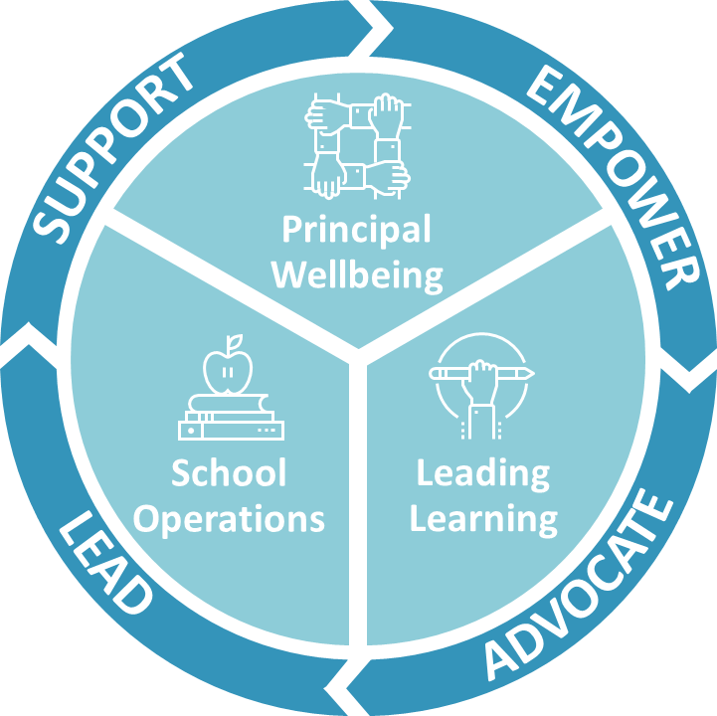

**AGENDA**

* Welcome: Robyn Evans
* Acknowledgement of Country: Robyn Evans
* NSWPPA Culture: Robyn Evans
* NSWPPA Priorities: Bob Willetts
* PPC Boundaries: Robyn Evans
* PPC President’s Handbook: Rob Walker
* PPC Executive Terms of Office: Robyn Evans
* Reference Groups, Working Parties, Standing Committees –Vacancies & Contacts: Rob Walker
* PPC Meeting Agendas (Robyn Evans)
* PPC Issues Proactive and Responsive (Robyn Evans)
* Questions
* Close